Activity No 1.
Title of the Event | Marketing Club Event “ Product concept presentation” | 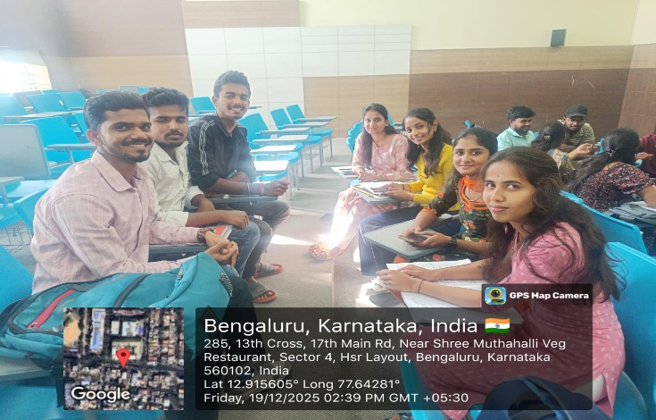
Day and Date | 19 December 2025
Venue (With all details ) | Seminar Hall -407
In collaboration with ( if any)
Details of Resource Person With Designation | Dr.Veto Dey | 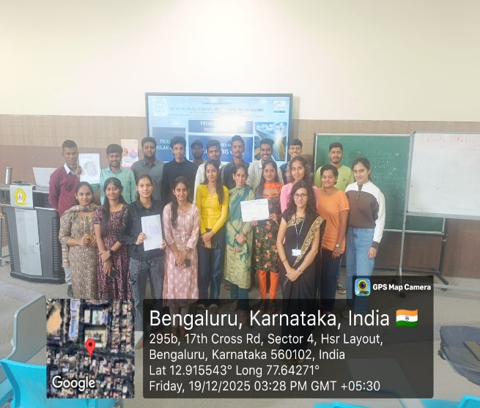
Organizing Department/Coordinators | Business Management,  Dr .Veto Dey
Course and semester | MBA I Sem
No of Students & Faculty Participants | 25

Coordinator HoD Vice-Principal Principal

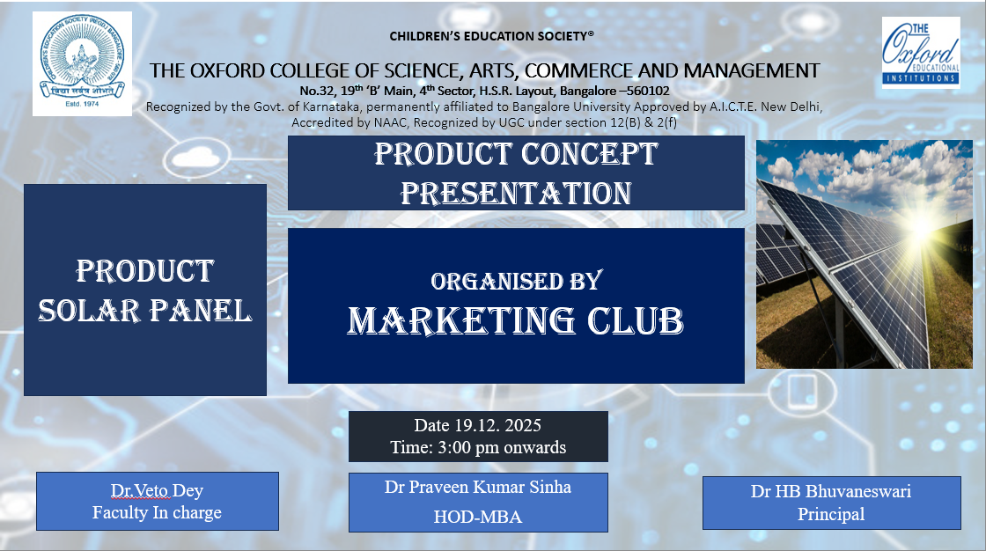
The Department of MBA organized a Product Concept Presentation on 19 December 2025 during the Marketing Club hour. The activity was conducted for MBA Semester I students, who presented an innovative solar panel product concept before a prospective funding panel.
The objective of the activity was to provide practical exposure to students in understanding product design, identification of Unique Selling Propositions (USP), and investor-oriented pitching. Students explained the product concept, highlighted its market relevance, and demonstrated how the product could address sustainability and energy needs.
Through interaction with the panel, students received constructive feedback on feasibility, pricing, differentiation, and market potential, which helped them refine their ideas from a business perspective. This interaction simulated a real startup pitching environment and exposed students to investor expectations.
The activity enhanced students’ presentation skills, analytical thinking, and confidence, while offering real-world insight into how product ideas are evaluated by potential investors. Overall, the session successfully bridged theoretical marketing concepts with practical application and encouraged entrepreneurial thinking among students.

